**CREATE AND RUN A JOB**

**STEPS**

**1.** Click in **New Item**

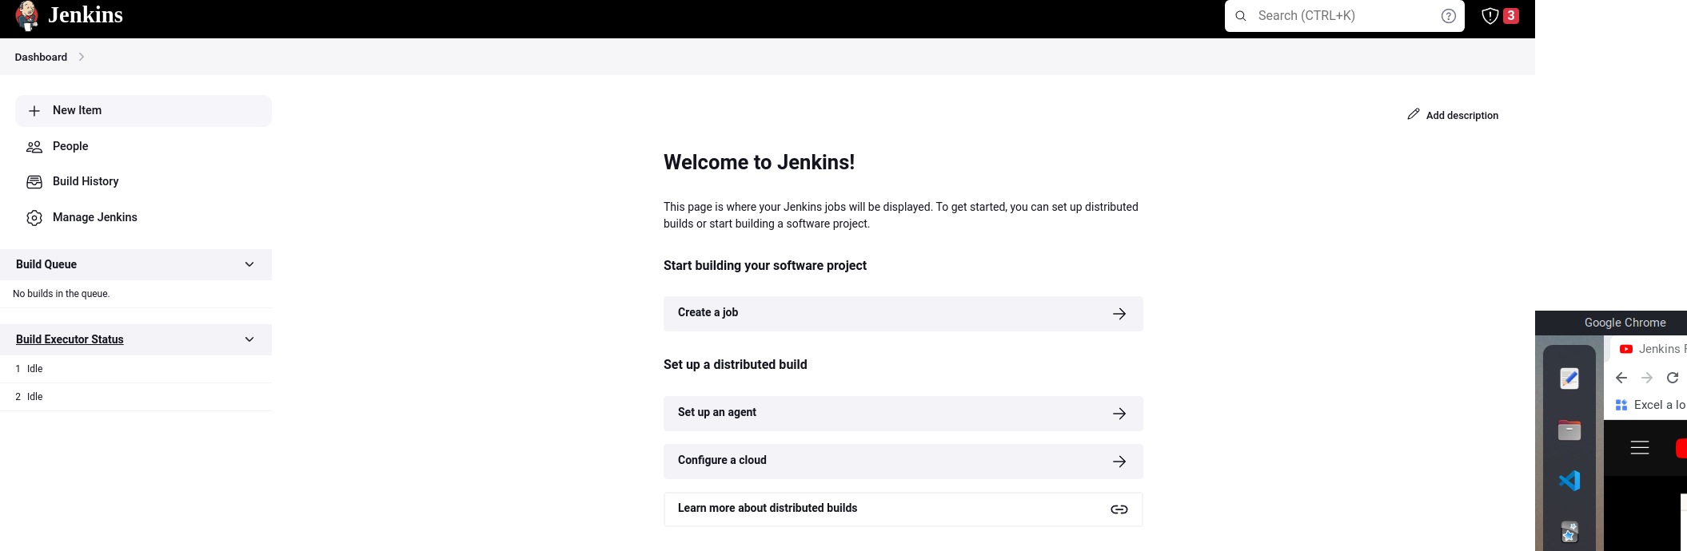

**2.** Put a name and select **Freestyle Project**

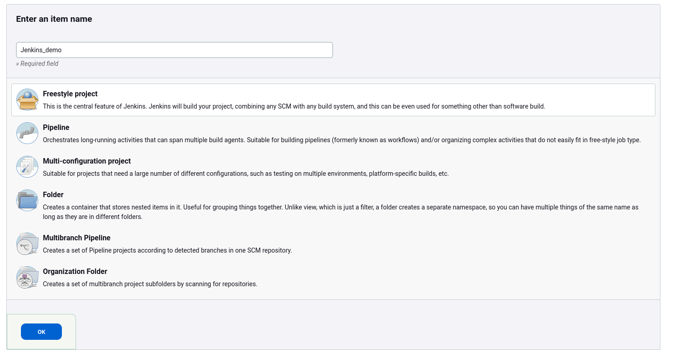

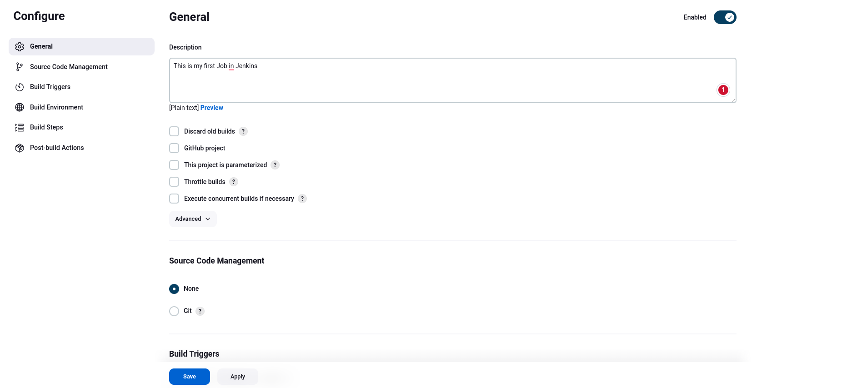

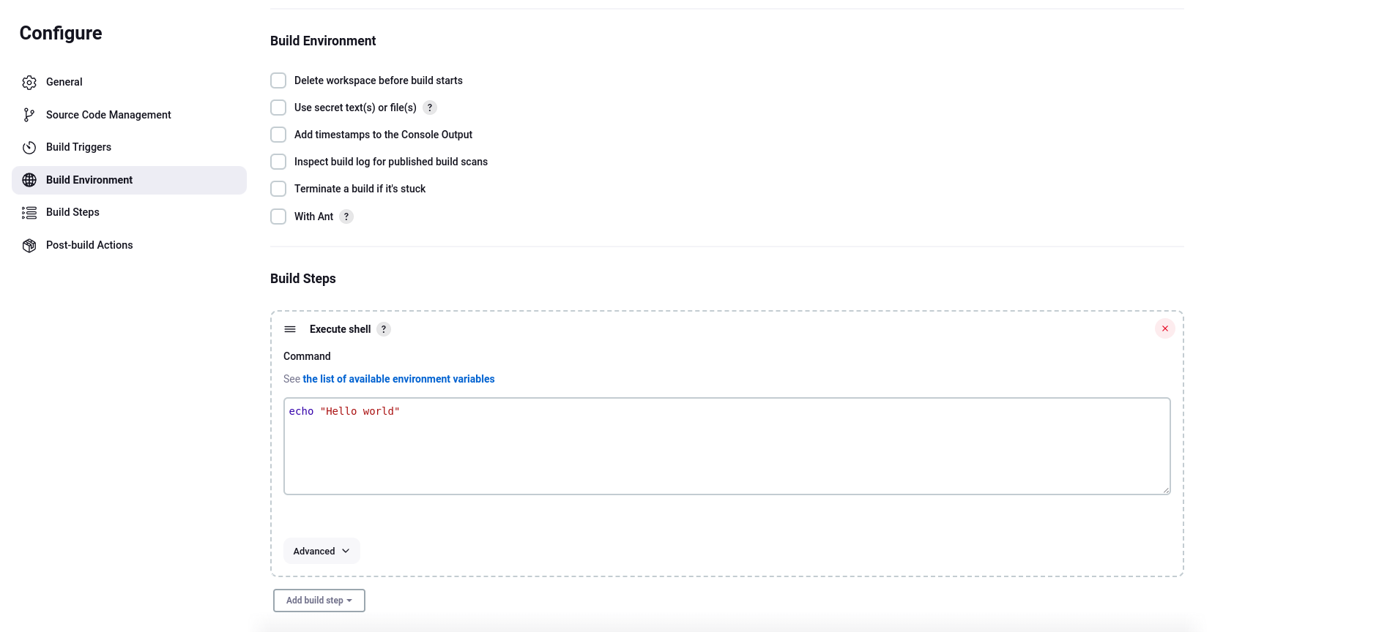

Apply and Save

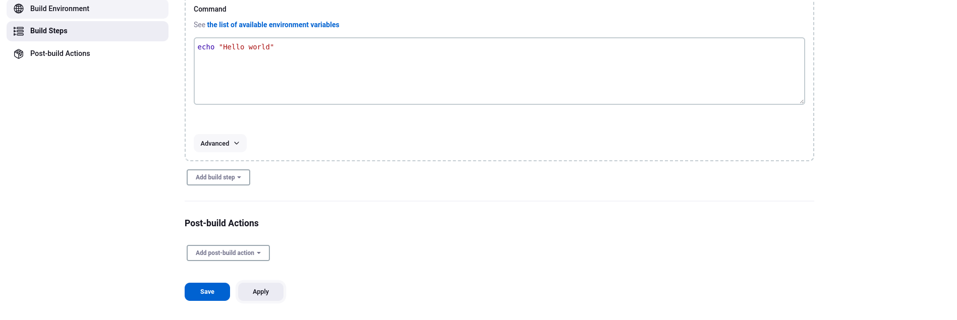

Click in **Build Now**

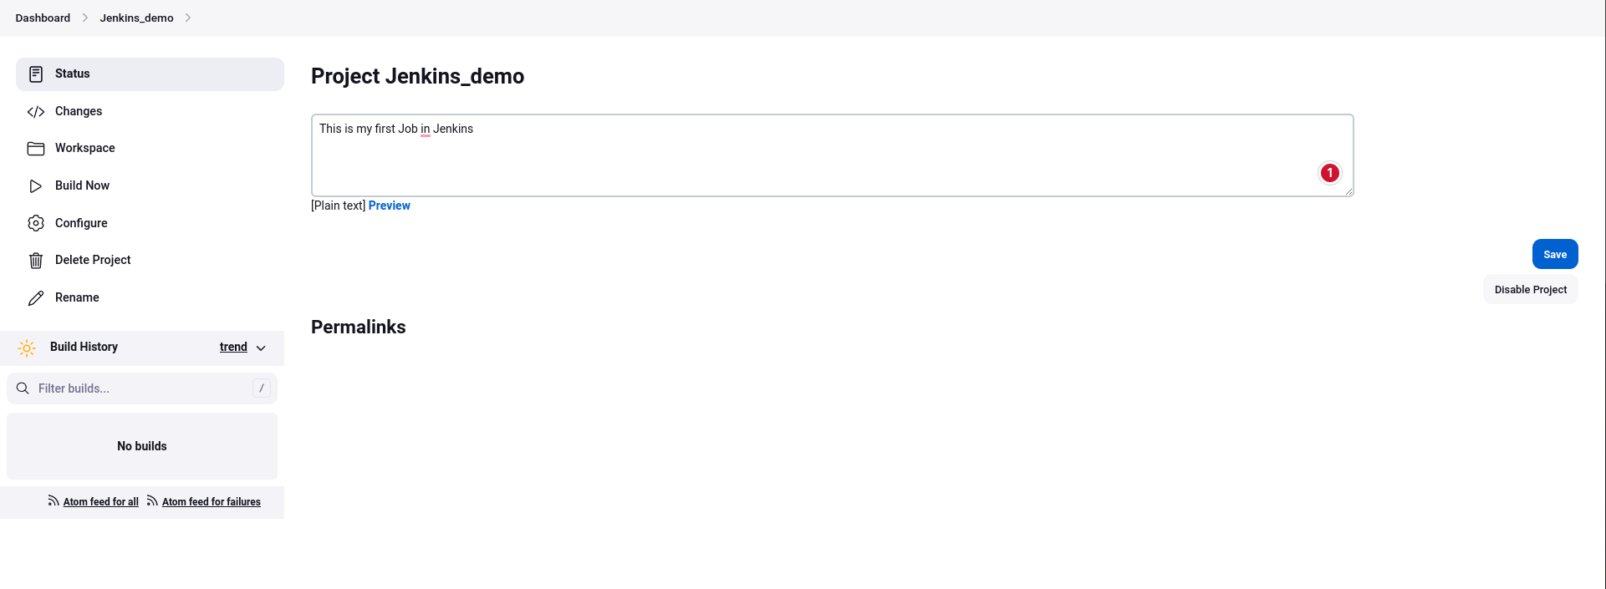

Click

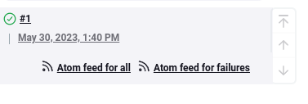

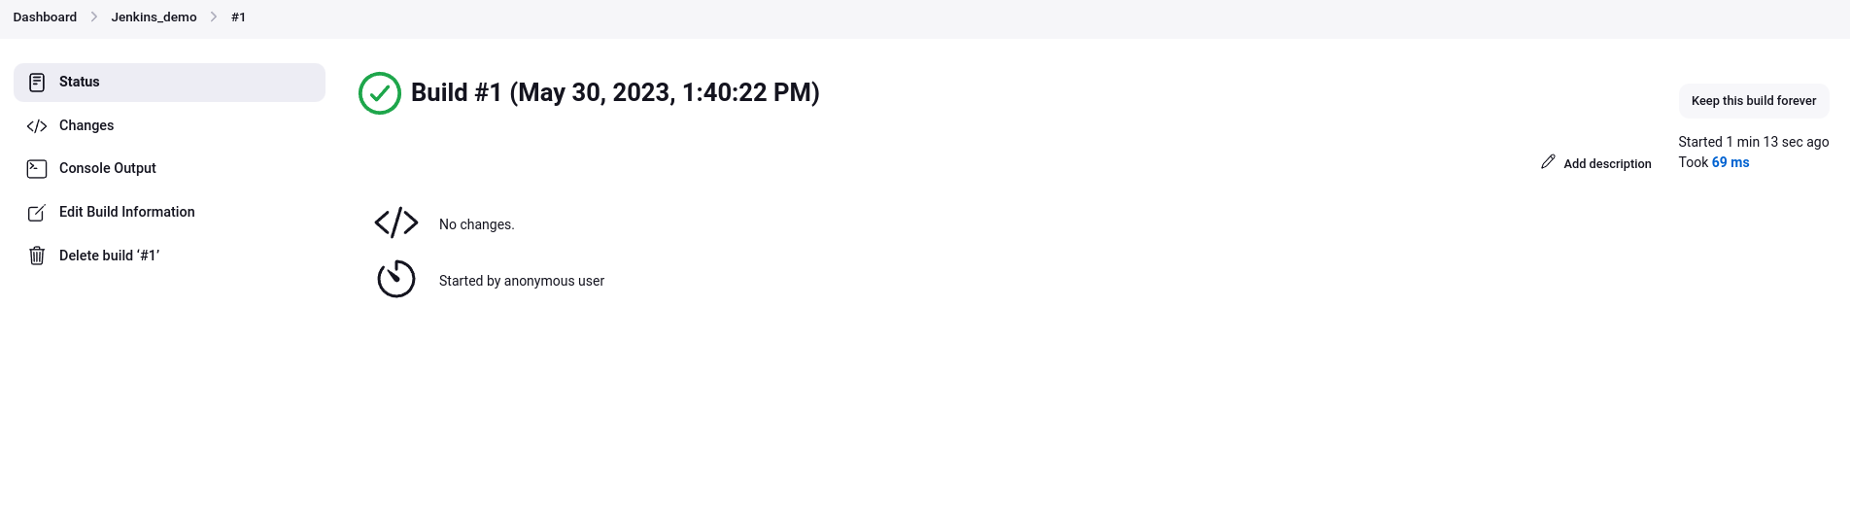

Check the console output

